**P.3 Integrated Science (LIT 1A)**

**SECTION A (30 MARKS)**

1. Name one living thing.

__________________________________________________________

1. Give one plant that gives us food.

__________________________________________________________

1. Which part of the body is used for walking?

__________________________________________________________

1. How are insects useful to people?

__________________________________________________________

1. Write any physical exercise you know.

__________________________________________________________

1. An___________________________ is a sudden happening that causes an injury or death. (**first aid**, **accident**)

_________________________________________________________

1. Name the main source of water?

_________________________________________________________

1. 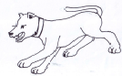**How useful is this animal at home?**

_________________________

1. Where does a crocodile live?

_________________________________________________________

1. Give one way you can care for your body. _________________________________________________________
2. Name the immunisable disease that makes children lame?

_________________________________________________________

1. What is the work of a dentist in our community?

________________________________________________________

1. **Name one thing kept in this box below.**

_________________________

1. Name one good health habit you should do after visiting the toilet.

__________________________________________________________

1. Write one product got from bees.

_________________________________________________________

1. State one energy giving food.

_________________________________________________________

1. Give one item used when cleaning our homes.

_________________________________________________________

1. **Name this type of weather.**

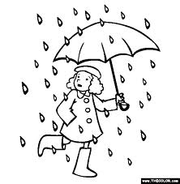

__________________________________________________________

1. Which animal lives in a Kennel?

__________________________________________________________

1. How do we make water safe for drinking?

***__________________________________________________________***

1. Write one basic need of man.

__________________________________________________________

1. Name the best food for babies below six months.

__________________________________________________________

23. **How is this item useful in a house?**

_______________________________________

24. What is the use of legs to animals?

__________________________________________________________

**Name these parts of a plant.**

|  |  |
| --- | --- |
| 25. | http://t1.gstatic.com/images?q=tbn:ANd9GcRqiJcDtg7eHprvHZIx_9pxOIoHW6fgSxDVjhjVOTU8uVHD6k4OVQ26. |
|  |  |

27. Why is a plant a living thing?

__________________________________________________________

28. Name one part found on the arm.

__________________________________________________________

29. Give one method of preparing food.

__________________________________________________________

30. Name one vector you know.

__________________________________________________________

31. Name one animal used for transport.

___________________________________________________________

32. Write down any one example of a wild animal.

___________________________________________________________

33. Apart from mushrooms, name one other example of a fungi.

___________________________________________________________

34. Draw and name one animal which reproduced by laying eggs.

____________________________

35. Mention one crop grown in the swamp.

___________________________________________________________

36. Identify the object that reflects light from the sun.

___________________________________________________________

37. Mention one method of planting crops.

___________________________________________________________

38. Why should a school have a school garden?

___________________________________________________________

39. Why is loam soil the best soil for growing crops?

___________________________________________________________

40. What do we call water in gas form?

___________________________________________________________

**SECTION B**

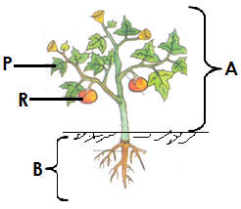41. Below is a flowering plant use it to answer questions that follow.

1. Name the parts of a plant marked

**P**____________________________

**R** ____________________________

b) Mention the system of a plant marked

**A**____________________________

**B** ____________________________

42. a) What do we call the removal of unwanted plants from the garden?

___________________________________________________________

b) Mention three ways farmers care for their crops in the garden.

i) ________________________________________________________

ii) ________________________________________________________

iii)_________________________________________________________

43. a) Mention two insects eaten by man

i) ___________________________ii) ___________________________

1. How many body parts does an insect have?

__________________________________________________________

1. Why are bees called social insects?

__________________________________________________________

44. a) What is soil profile?

___________________________________________________________

___________________________________________________________

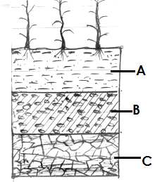b) Name the layers of soil shown in the diagram below.

i) A________________________________

ii) B________________________________

iii) C _______________________________

45. a) What are seedlings?

___________________________________________________________

___________________________________________________________

b) Besides moisture, name two other conditions needed for seeds to germinate.

i)__________________________________________________________

ii)_________________________________________________________

c) Mention one example of a seed.

___________________________________________________________

46. a) What do we call the mixture of gases in the atmosphere?

___________________________________________________________

b) Write down any two gases in the atmosphere.

i)_________________________ ii)_________________________

c) What is wind?

___________________________________________________________

___________________________________________________________

47. Complete the table below by filling in the missing information.

|  |  |  |
| --- | --- | --- |
|  | **Animal** | **Habitat** |
| i) | __________ | Stable |
| ii) | Bird | _____________ |
| iii) | ___________ | Sty |
| iv) | Lion | _______________. |

48. a) Name the garden tools below

|  |  |  |  |
| --- | --- | --- | --- |
|  |  |  |  |
|  |  |  |  |

49. a) What is environment?

___________________________________________________________

___________________________________________________________

b) Write down any two living components of environment.

i)__________________________________________________________

ii)_________________________________________________________

c) Give another word to mean environment.

___________________________________________________________

50. How do the following animals move

1. snake ____________________________________________________
2. man_____________________________________________________
3. bees_____________________________________________________
4. fish_____________________________________________________

51. a) A_____________________________is unexpected danger.

b) Mention two reasons why we give First Aid to accident victims.

i)__________________________________________________________

ii)_________________________________________________________

1. What do we call a person who gives First Aid?

___________________________________________________________

52. a) Which part of the following plants do we eat?

1. banana_____________________ ii) cabbage __________________

iii) beans_____________________ iv) cassava___________________

53. a) Mention any two sources of water.

i)__________________________________________________________

ii)_________________________________________________________

b) Write down two uses of water at home.

i)__________________________________________________________

ii)_________________________________________________________

54. a) Match the items in A to those in B.

|  |  |  |
| --- | --- | --- |
|  | **A** | **B** |
| i) | Nose | Used for seeing. |
| ii) | Ear | Used for smelling. |
| iii) | Tongue | Used for hearing. |
| iv) | eye | Used for tasting food. |

|  |  |  |
| --- | --- | --- |
| i) | Nose | ________________________________________ |
| ii) | Ear | ________________________________________ |
| iii) | Tongue | ________________________________________ |
| iv) | eye | ________________________________________ |

55. The diagram below shows water animal. Use it to answer questions that follow.

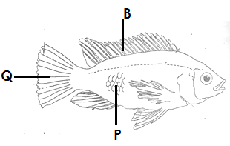

1. Name the water animal shown in the diagram.

__________________________________________________________

b) Name parts marked **P** and **Q**.

i) **P**_______________________________________________________

ii) **Q**______________________________________________________

c) How is part B useful to the above animal

___________________________________________________________

GOOD LUCK